Project Design Phase-II
Technology Stack (Architecture & Stack)
Date | 31 January 2025
Team ID | ________________
Project Name | Automated Network Request Management in ServiceNow
Maximum Marks | 4 Marks
Technical Architecture:
The proposed technical architecture uses ServiceNow as the central IT Service Management platform. It connects requesters, approvers, network fulfillment teams and administrators through a standardized service catalog, automated workflow, business logic, data storage, notifications, reporting and optional external integrations.
Architecture Flow: Users → ServiceNow Employee Center / Service Portal → Network Service Catalog → Request Forms & Validation → Flow Designer → Approval & Assignment → Network Fulfillment → Notifications & Tracking → Reporting / Audit
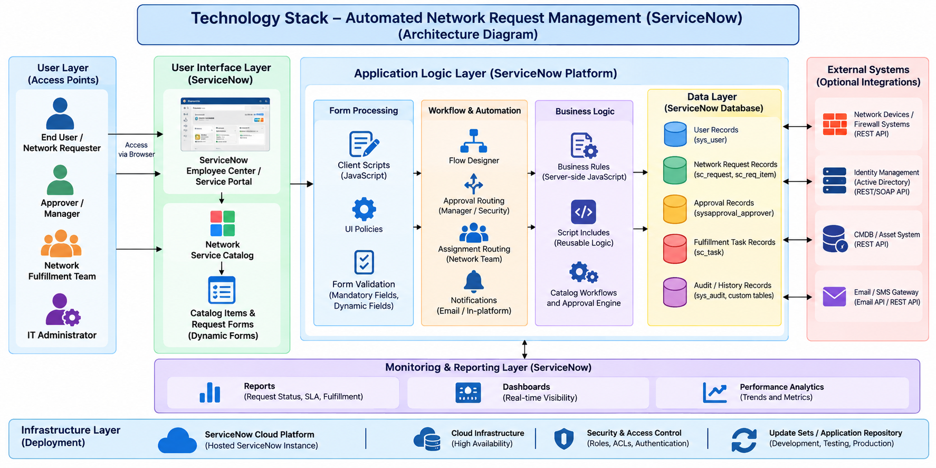
Figure 1: Proposed Technical Architecture – Automated Network Request Management
Table-1: Components & Technologies
S.No | Component | Description | Technology
1 | User Interface | Interface for submitting and tracking network requests. | ServiceNow Employee Center / Service Portal, Service Catalog
2 | Application Logic-1 | Client-side form behavior, mandatory fields, validation and dynamic fields. | Client Scripts, UI Policies, JavaScript
3 | Application Logic-2 | Server-side processing, business rules and reusable application logic. | Business Rules, Script Includes, JavaScript
4 | Application Logic-3 | Workflow automation, approvals, assignment, tasks and notifications. | Flow Designer, Approval Engine, ServiceNow Notifications
5 | Database | Stores users, requests, approvals, tasks, status and history. | ServiceNow Platform Database / ServiceNow Tables
6 | Cloud Database | Central platform data storage; no separate external database is required for the core solution. | ServiceNow Platform Database
7 | File Storage | Stores supporting attachments when required by network requests. | ServiceNow Attachment Storage
8 | External API-1 | Optional integration with network devices or firewall systems for fulfillment. | REST API / IntegrationHub
9 | External API-2 | Optional integration with identity, CMDB/asset or enterprise systems. | REST / SOAP APIs / IntegrationHub
10 | Machine Learning Model | Not required because the proposed project focuses on workflow and IT service automation. | N/A
11 | Infrastructure (Server / Cloud) | Hosts the application and platform services for authorized users. | ServiceNow Cloud Platform / ServiceNow Instance
Table-2: Application Characteristics
S.No | Characteristics | Description | Technology
1 | Open-Source Frameworks | The core solution is built on the ServiceNow platform and does not require a separate open-source application framework. | JavaScript / ServiceNow Platform APIs
2 | Security Implementations | Role-based access, authentication, authorization, ACLs and audit logging protect request and administrative data. | ServiceNow Roles, ACLs, Authentication, Authorization, Audit Logs, OWASP practices
3 | Scalable Architecture | New request types, users, approval rules and fulfillment groups can be added without redesigning the complete solution. | Service Catalog, Flow Designer, reusable configuration and platform tables
4 | Availability | The proposed solution is hosted on the ServiceNow cloud platform and is accessible to authorized users through a web browser. | ServiceNow Cloud Platform / platform availability capabilities
5 | Performance | Standardized forms, validation, efficient queries and automated flows reduce unnecessary manual processing and workflow delays. | ServiceNow Platform, Client Scripts, Business Rules, Flow Designer
Technology Stack Summary
Layer | Selected Technology
User Interface | ServiceNow Employee Center / Service Portal
Service Catalog | ServiceNow Service Catalog
Form Logic | Client Scripts, UI Policies, JavaScript
Server Logic | Business Rules, Script Includes
Automation | Flow Designer
Approval | ServiceNow Approval Management
Database | ServiceNow Platform Database
Integration | REST/SOAP APIs, IntegrationHub
Security | Roles, ACLs, Authentication, Authorization
Reporting | Reports, Dashboards, Performance Analytics
Hosting | ServiceNow Cloud Platform
Note: External integrations shown in the architecture are optional extension points. The core project can operate using ServiceNow's native catalog, workflow, database, notification, security and reporting capabilities.
References
ServiceNow Documentation – https://www.servicenow.com/docs/
ServiceNow Developer – https://developer.servicenow.com/
C4 Model – https://c4model.com/
IBM Cloud Architecture – https://www.ibm.com/cloud/architecture
AWS Architecture – https://aws.amazon.com/architecture

